**System and Data Modeling**

Title: FAMS: Financial Assistance Management System for ABC Municipality Utilizing C4.5 Algorithm

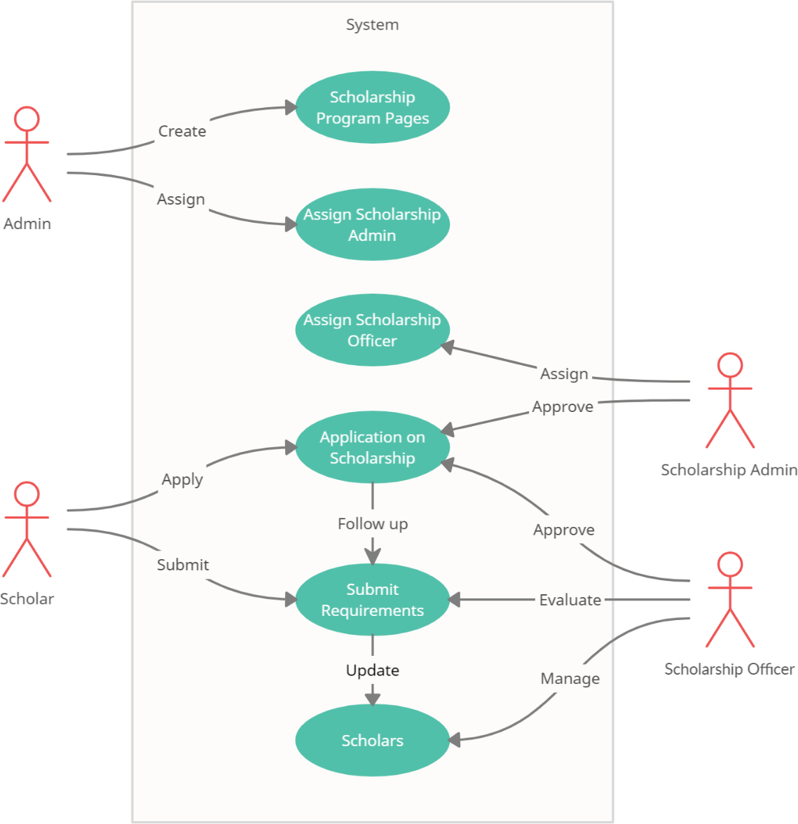

The Use case Diagram above shows the representation of user’s interaction that in their relationship between other users.